Lab 2 – MySQL and DDL

Lab Introduction

Objective
To familiarize with WAMP environment and PHPMyAdmin GUI. Create a database and apply SQL statements to create the tables as instructed in the table structure. To apply the SQL statements to inset data in the tables.

Timeline
Approximate time to complete task | 30 mins

Pre-requirements
- Install WAMP server according to the installation guide
- Check if the Apache and MySQL services are up and running
- For all the tasks, we use the tool “PHPMyAdmin”.
- The link http://localhost/phpmyadmin/ should be up and running.

Task
The students should complete the below tasks:
- Create a database called LabCADA. Schema, Lab will have five tables.
- Create four tables in LabCADA using SQL Create Statements. The Logical design layout for the tables is as follows.
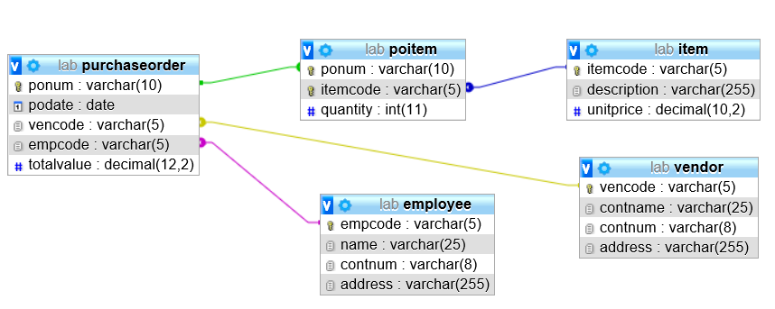

Figure 1: Physical design for the schema, Lab.

- The data for the schema is given below. Insert the data into parent tables and then into child tables. Use SQL Insert statements.

EMPLOYEE
empcode | Name | contnum | address
E0001 | Henry Lim | 65424587 | 10 Cluny Road, Singapore 421232
E0002 | Samantha Tan | 65424586 | 128 Beaty Road, Singapore 231232
E0003 | Jodie Chan | 65425977 | 7 Queenstown Avenue, #12-22, Singpaore 402189
E0004 | Tan Peng Chan | 65425678 | 34 Crescent Road, #08-13, Singapore 892012
E0005 | Andy Heng | 65425713 | 16 Pasir Ris Drive, #18-09, Singapore 123401
E0006 | Dan Lee | 65428797 | 54 Jurong West Avenue 21, #05-12, Singapore 212822
E0007 | Jade Wu | 65420127 | 394 Bukit Timah Road, Singapore 359201
E0008 | George Lim | 65420782 | 45 Thomson Road, #09-32, Singpaore 129045
E0009 | Goh Eng Bun | 65420872 | 24 Tampines Avenue 5, #16-33, Singapore 349081
E0010 | Charles Ang | 65429878 | 67 Baker Road, Singapore 092412

VENDOR
vencode | contname | contnumber | address
V0001 | John Tan | 98722458 | 10 Woodlands Avenue 2, Singapore 754965
V0002 | Alicia Wu | 94213785 | 24 Changi Business Park, #02-34, Maxwell Building, Singapore 475327
V0003 | Chan Lee Lee | 86275495 | 23 Bedok Road, Singapore 456355
V0004 | Jack Sim | 91256783 | 34 Sungei Kadut Avenue, Singapore 789453
V0005 | Ken Chua | 94758932 | 30 Thomson Drive, #20-23, Tong Tong Building, Singapore 458789
V0006 | Betty Goh | 87549636 | 88 East Coast Road, Singapore 4567254

PURCHASE ORDER
ponum | podate | vencode | empcode | totalvalue
P000000001 | 24/5/2018 | V0002 | E0005 | 14000
P000000002 | 24/5/2018 | V0006 | E0005 | 16700
P000000003 | 6/6/2018 | V0003 | E0003 | 700
P000000004 | 8/6/2018 | V0001 | E0010 | 3500
P000000005 | 8/6/2018 | V0005 | E0008 | 760
P000000006 | 12/6/2018 | V0004 | E0008 | 4000
P000000007 | 16/6/2018 | V0006 | E0005 | 1900
P000000008 | 16/6/2018 | V0004 | E0008 | 4000
P000000009 | 20/6/2018 | V0004 | E0008 | 2000
P000000010 | 24/6/2018 | V0001 | E0010 | 1750
P000000011 | 28/6/2018 | V0002 | E0005 | 2400
P000000012 | 3/7/2018 | V0005 | E0010 | 1080
P000000013 | 4/8/2018 | V0002 | E0003 | 350
P000000014 | 12/8/2018 | V0002 | E0008 | 1800
P000000015 | 12/8/2018 | V0005 | E0008 | 1520

ITEM
itemcode | description | unitprice
I0001 | Office chair with wheels and high neck rest | 800
I0002 | Office chair with wheels | 600
I0003 | White computer desk 200cm X 60cm | 950
I0004 | White computer desk 140cm X 60cm | 720
I0005 | Cabinets with 4 drawers 80cm X 140cm | 800
I0006 | Cabinets with 3 drawers 60cm X 80cm | 600
I0007 | Apple iPhone X Black 256GB | 2000
I0008 | Apple iPhone X Rose Gold 256GB | 2000
I0009 | Apple iPhone 8 Black 128GB | 1600
I0010 | Glass meeting table 200cm X 80cm | 2400
I0011 | Office White board 180cm X 120cm | 350
I0012 | Book Shelves Brown 160cm X 200cm | 760
I0013 | Book Shelves Brown 140cm X 120cm | 540
I0014 | Samsung S9 256GB Rose Gold | 1750
I0015 | Samsung S9 256GB Black | 1750

POITEM
ponum | itemcode | quantity
P000000001 | I0001 | 10
P000000001 | I0002 | 10
P000000002 | I0003 | 10
P000000002 | I0004 | 10
P000000003 | I0011 | 2
P000000004 | I0014 | 2
P000000005 | I0012 | 1
P000000006 | I0007 | 2
P000000007 | I0003 | 2
P000000008 | I0008 | 2
P000000009 | I0007 | 5
P000000010 | I0015 | 1
P000000011 | I0001 | 3
P000000012 | I0013 | 3
P000000013 | I0011 | 1
P000000014 | I0006 | 3
P000000015 | I0012 | 2

LAB Activity

Lab Task 1: Create a database
- Click WAMP5 service on the task bar. Click MySQL and check if the service is running. If not start the service. Click phpMyAdmin.

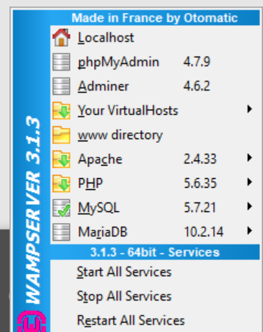
Click on PHPMyAdmin

- The following login window is shown up. Set the password to the one you set during the installation of WAMP.

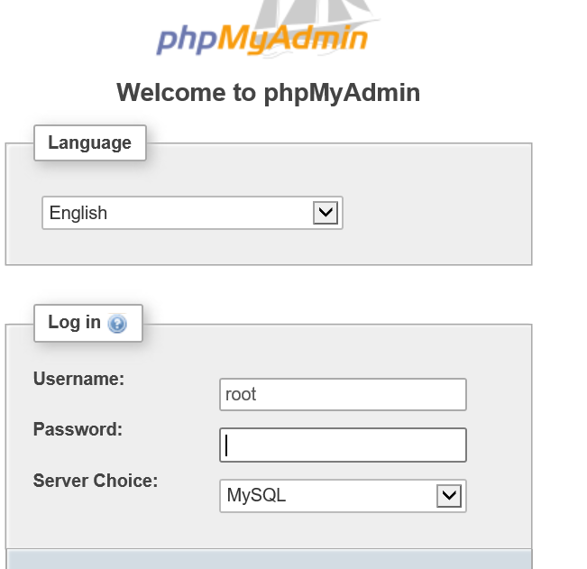
Default:
Username=root. Password=

- After login the following screen pops up.
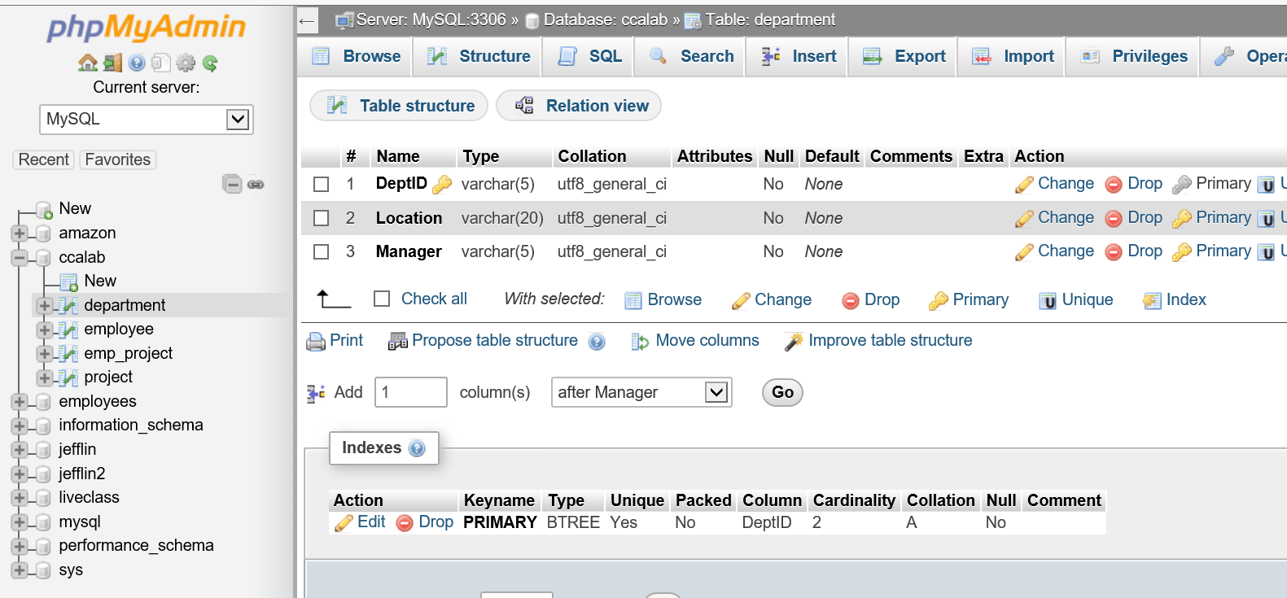
Table structure if any tables.
List of databases
Tabs to execute SQL statements

- To create a database, click New in left panel of the database tree view. Enter the value Lab and click "Create".
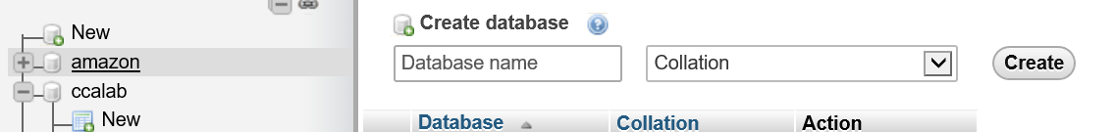

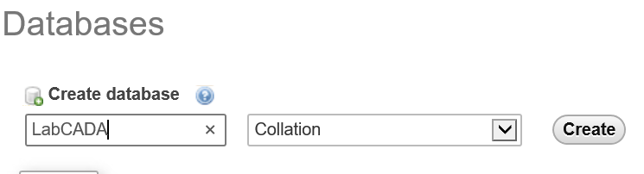

- The following window is shown.
A new Database is created.

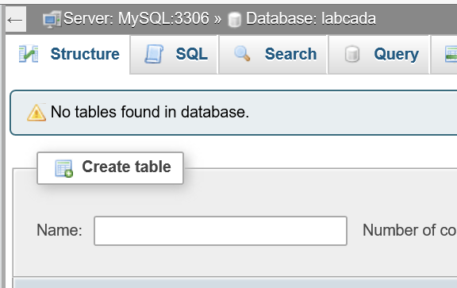
No tables yet.

Lab Task 2: Creating tables
Here we will be creating tables for the LabCADA.

- In the SQL tab type the following.

create table employee
(empcode varchar(5) not null,
name varchar(25),
contnum varchar(8),
address varchar(255),
constraint emp_pk primary key (empcode));

 | What are the constraints for the table, EMPLOYEE?

- Goto SQL tab. Type the SQl statement. To execute the code you can press "Go".

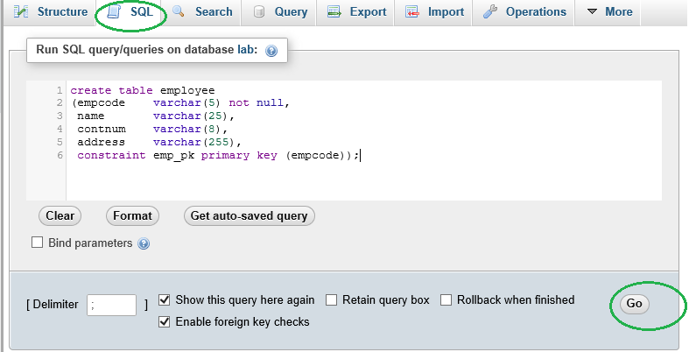

- Create vendor table as shown below;

create table vendor
(vencode varchar(5) not null,
contname varchar(25),
contnum varchar(8),
address varchar(255),
constraint ven_pk primary key (vencode));

- The table can found in the object browser after you select the Database from the list to your left.

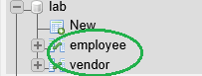

- Create the remaining tables with the following scripts.

create table item
(itemcode varchar(5) not null,
description varchar(255),
unitprice decimal(10,2),
constraint item_pk primary key (itemcode));

create table purchaseorder
(ponum varchar(10) not null,
podate date,
vencode varchar(5),
empcode varchar(5),
totalvalue decimal(12,2),
constraint po_pk primary key (ponum),
constraint po_fk1 foreign key (vencode) references vendor(vencode),
constraint po_fk2 foreign key (empcode) references employee(empcode));

- Create table poitem.

What are the constraints for the poitem?

Task 3: Insert data to the tables
Creation of data – What is order for tables | 1. EMPLOYEE 2. ? 3. ? 4.? 5.?
How to represent the date value?

- Goto SQL Tab. Enter the SQL insert statements in the new script tab and click Go to execute all these statements.

insert into employee values
("E0001","Henry Lim",65424587,"10 Cluny Road, Singapore 421232"),
("E0002","Samantha Tan",65424586,"128 Beaty Road, Singapore 231232"),
("E0003","Jodie Chan",65425977,"7 Queenstown Avenue, #12-22, Singapore 402189"),
("E0004","Tan Peng Chan",65425678,"34 Crescent Road, #08-13, Singapore 892012"),
("E0005","Andy Heng",65425713,"16 Pasir Ris Drive, #18-09, Singapore 123401"),
("E0006","Dan Lee",65428797,"54 Jurong West Avenue 21, #05-12, Singapore 212822"),
("E0007","Jade Wu",65420127,"394 Bukit Timah Road, Singapore 359201"),
("E0008","George Lim",65420782,"45 Thomson Road, #09-32, Singapore 129045"),
("E0009","Goh Eng Bun",65420872,"24 Tampines Avenue 5, #16-33, Singapore 349081"),
("E0010","Charles Ang",65429878,"67 Baker Road, Singapore 092412");

insert into vendor values
("V0001","John Tan",98722458,"10 Woodlands Avenue 2, Singapore 754965"),
("V0002","Alicia Wu",94213785,"24 Changi Business Park, #02-34, Maxwell Building, Singapore 475327"),
("V0003","Chan Lee Lee",86275495,"23 Bedok Road, Singapore 456355"),
("V0004","Jack Sim",91256783,"34 Sungei Kadut Avenue, Singapore 789453"),
("V0005","Ken Chua",94758932,"30 Thomson Drive, #20-23, Tong Tong Building, Singapore 458789"),
("V0006","Betty Goh",87549636,"88 East Coast Road, Singapore 4567254");

insert into item values
("I0001","Office chair with wheels and high neck rest",800),
("I0002","Office chair with wheels",600),
("I0003","White computer desk 200cm X 60cm",950),
("I0004","White computer desk 140cm X 60cm",720),
("I0005","Cabinets with 4 drawers 80cm X 140cm",800),
("I0006","Cabinets with 3 drawers 60cm X 80cm",600),
("I0007","Apple iPhone X Black 256GB",2000),
("I0008","Apple iPhone X Rose Gold 256GB",2000),
("I0009","Apple iPhone 8 Black 128GB",1600),
("I0010","Glass meeting table 200cm X 80cm",2400),
("I0011","Office White board 180cm X 120cm",350),
("I0012","Book Shelves Brown 160cm X 200cm",760),
("I0013","Book Shelves Brown 140cm X 120cm",540),
("I0014","Samsung S9 256GB Rose Gold",1750),
("I0015","Samsung S9 256GB Black",1750);

insert into purchaseorder values
("P000000001","2018-05-24","V0002","E0005",14000),
("P000000002","2018-05-24","V0006","E0005",16700),
("P000000003","2018-06-06","V0003","E0003",700),
("P000000004","2018-06-08","V0001","E0010",3500),
("P000000005","2018-06-08","V0005","E0008",760),
("P000000006","2018-06-12","V0004","E0008",4000),
("P000000007","2018-06-16","V0006","E0005",1900),
("P000000008","2018-06-16","V0004","E0008",4000),
("P000000009","2018-06-20","V0004","E0008",2000),
("P000000010","2018-06-24","V0001","E0010",1750),
("P000000011","2018-06-28","V0002","E0005",2400),
("P000000012","2018-07-03","V0005","E0010",1080),
("P000000013","2018-08-04","V0002","E0003",350),
("P000000014","2018-08-12","V0002","E0008",1800),
("P000000015","2018-08-12","V0005","E0008",1520);

insert into poitem values
("P000000001","I0001",10),
("P000000001","I0002",10),
("P000000002","I0003",10),
("P000000002","I0004",10),
("P000000003","I0011",2),
("P000000004","I0014",2),
("P000000005","I0012",1),
("P000000006","I0007",2),
("P000000007","I0003",2),
("P000000008","I0008",2),
("P000000009","I0007",5),
("P000000010","I0015",1),
("P000000011","I0001",3),
("P000000012","I0013",3),
("P000000013","I0011",1),
("P000000014","I0006",3),
("P000000015","I0012", 2);

LAB 2 SOLUTION
Syntax for table, poitem

create table poitem
(ponum varchar(10),
itemcode varchar(5),
quantity int,
constraint poitem_pk primary key (ponum, itemcode),
constraint poitem_fk1 foreign key (ponum) references purchaseorder(ponum),
constraint poitem_fk2 foreign key (itemcode) references item(itemcode));

